|  |
| --- |
|  |
|  |
| **TESTER User Manual**  **---------------**  Automated Test with the Robot |

|  |
| --- |
| **Tester User Manual** |

Contents

Foreword 3

Login 4

User Interface 4

User interface for the editing 5

User Interface 5

Control Panel 6

User Interface 6

Dashboard 8

User Interface 8

Logfile 10

Gallery 11

Reference 12

Reference Edit 13

Reference Export 14

Reference Import 15

Dataset 16

User Interface: Dataset 16

User Interface: Dataset Edit 17

User Interface: Dataset Import 18

User Interface: Data 19

User Interface: Data Edit 26

Dummy User 27

User Interface 27

User Interface: Edit 28

# **Foreword**

This user manual will give you information on how to use the robot as a Tester.

**Tester actions:**

The Tester is responsible for:

* The execution of the Stories
* The management of the Datasets
* The management of the Dummy Users

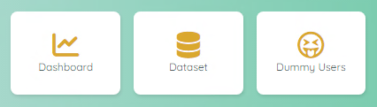

# **Login**

|  |
| --- |
| User Interface |

To access to the Robot, you need to have a login.  
After you successfully register to the application as a new user (Guess), you have to wait that the Administrator will assign you a Role to a project (or multiple projects).

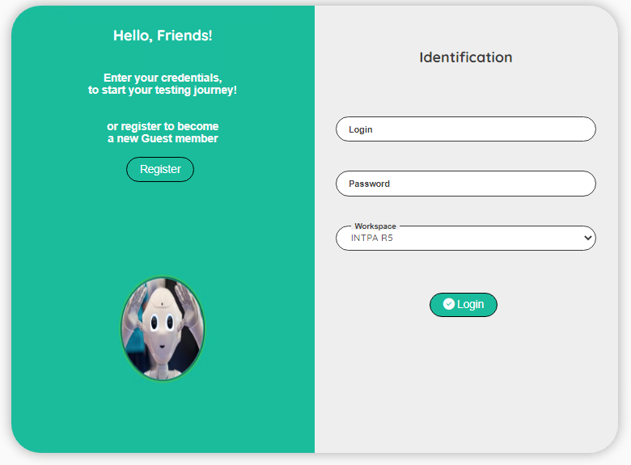

| **Topic** | **Icon** | **Comment** |
| --- | --- | --- |
| Register |  | Click to Register as a new user |
| Login |  | Enter your login |
| Password |  | Enter your password |
| Workspace |  | Enter your workspace |
| Login |  | Click to login to the Robot |

# **User interface for the editing**

|  |
| --- |
| User Interface |

We use the same user interface when editing a record.  
To avoid repeating the same explanation all the time, you will find here a generic explanation on how to use the edit interface.  
When you have the permission to edit a record, you will see the following icons:  


| **Topic** | **Icon** | **Comment** |
| --- | --- | --- |
| Delete | or | Delete a record (a confirmation is required!) To delete multiple records, select the records first. |
| Edit |  | Go to a screen to update the record. |
| Copy |  | First select the record to copy and then click on the copy icon. Record(s) will be set after the copy icon. |
| Move |  | First select the record to move and then click on the move icon. Record(s) will be set after the move icon. |
| Select / Unselect | / | Select or unselect a record |

Depending of the context, some extra icon(s) can be available.  
The extra icon(s) will be explain in the section dedicated to the context.

# **Control Panel**

|  |
| --- |
| User Interface |

The dashboard will allow you to execute pre-defined stories.  
If you are assign to a **TESTER** role, your user interface will look like this:

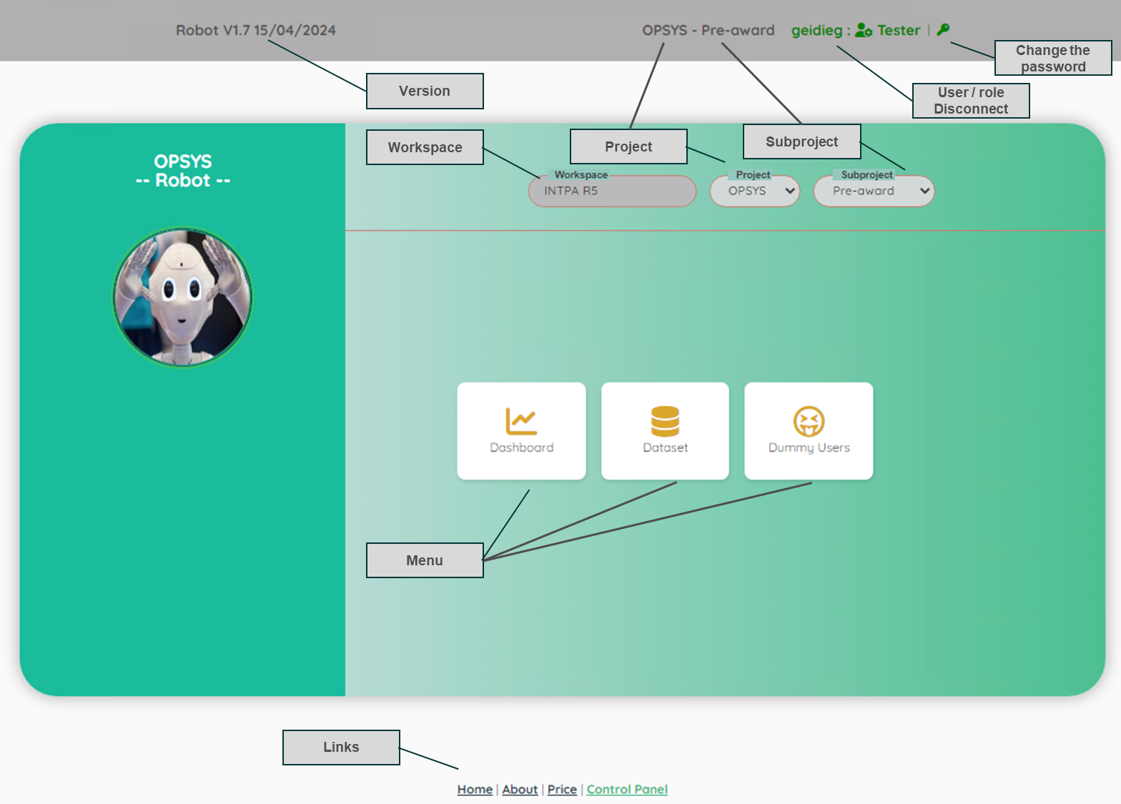

| **Topic** | **Comment** |
| --- | --- |
| Version | Version of the Robot. |
| Workspace | For info: the name of the workspace of the customer. |
| Project | List of the project(s) that you have access (assignment to a project is done by an Administrator). |
| Subproject | Access to all the subproject(s) of the selected project. |
|  | When executing a story, you can stop the execution. |
| User/Role Disconnect | For info: your login and your role. If you click on the ‘User/Role’, you will be disconnected from the application. |
| Change the password | Click on the icon to change your current password |
| Menu | Click on the items to open a new section of the application |
| Links | Useful links |

If you are assign to a **DESIGNER** or an **ADMIN** role, your user interface will look like this:

On the right side of the control panel, you have additional roles

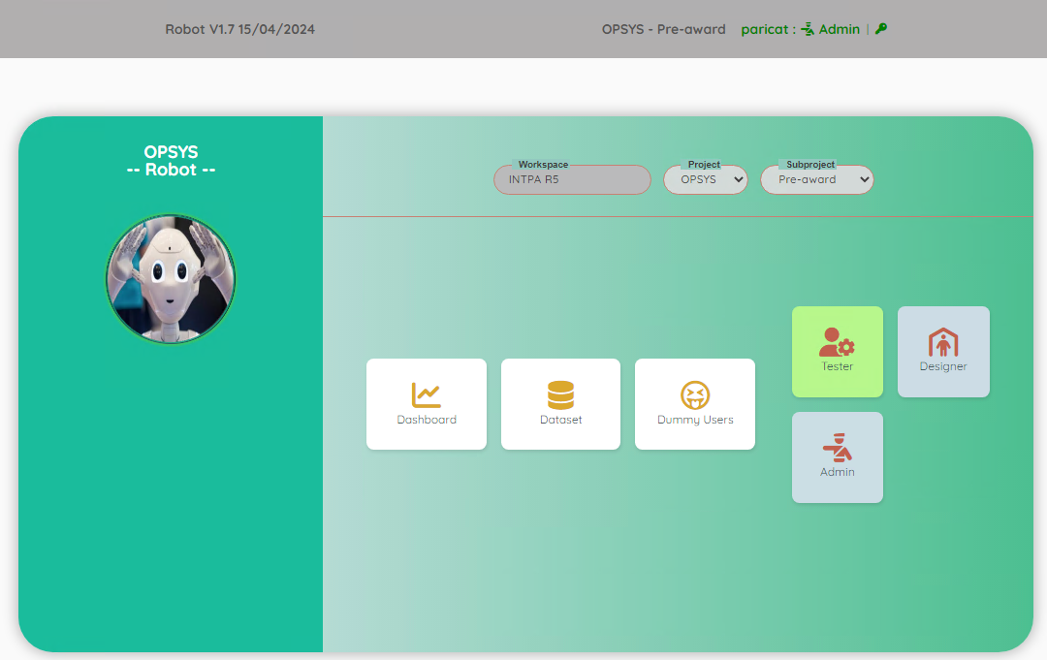

# **Dashboard**

|  |
| --- |
| User Interface |

The dashboard will allow you to execute pre-defined stories.  
A story is a test case prepared by a Designer.  
A story is divided into steps, you can execute one story at a time or all stories at once.

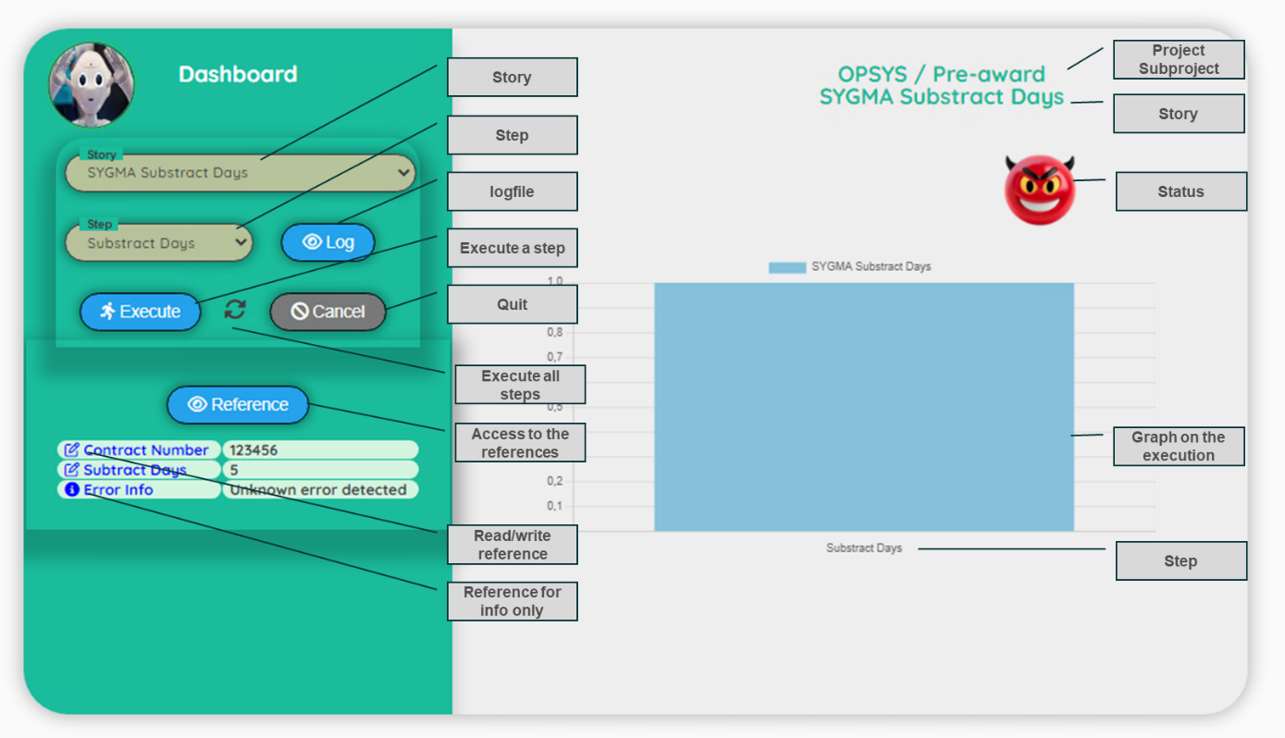

| **Topic** | **Icon** | **Comment** |
| --- | --- | --- |
| Story |  | A list with all the stories available |
| Step |  | A list with all the steps of the selected story |
| Log |  | Access to the logfile |
| Execute a step |  | Execute a step (or all steps) of a story |
|  |  | When executing a story, you can stop the execution |
| Execute all steps |  | Execute all the steps of a story |
| Execute stop if error |  | In case of error, the robot stops the execution of all the steps |
| Execute retry if error |  | In case of error, the robot will retry 5 times |
| Quit |  | Quit the Dashboard to return to the Control panel |
| Reference |  | Go to the Reference screen |
| Read/write reference |  | This reference will be available (in the reference screen) as an updatable field |
| Reference for info only |  | This reference is only for your information, you cannot update it |
| Status |  | Test in progress…. Please wait |
|  |  | Test is OK |
|  |  | Test fails |
|  |  | Test fails, first time (only if you ask to execute all the steps of a story) |
|  |  | Test fails, second attempt (only if you ask to execute all the steps of a story) |
|  |  | Test fails, third attempt (only if you ask to execute all the steps of a story) |
|  |  | Test fails, fourth (and last) attempt (only if you ask to execute all the steps of a story) |
| Graph |  | Show you the number of execution of the steps and the progress in the execution of the story. |

|  |
| --- |
| Logfile |

The logfile will show you all the steps executed with extra information.  
It helps you to understand how the test has been executed.  
Note: There is one logfile by user. You see always the logfile of the last execution

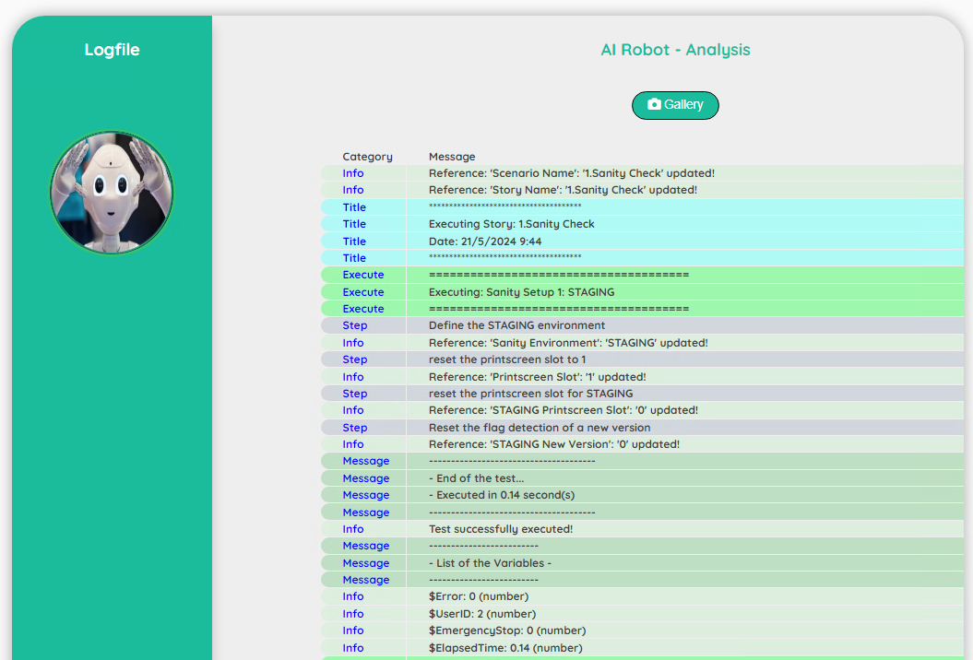

| **Topic** | **Icon** | **Comment** |
| --- | --- | --- |
| Gallery |  | Access to the print screen(s) |

|  |
| --- |
| Gallery |

The gallery will show you the print screen taken during the execution of the story.  
The first print screen is done automatically by the Robot when an error occurs (it will show you the last error detected – in case of success of a story, you will see the last error detected)

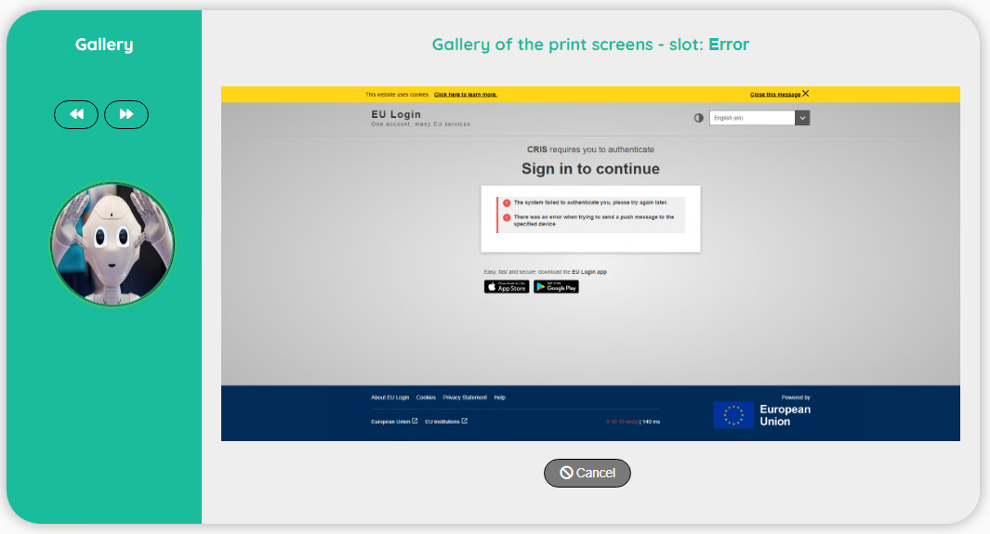

| **Topic** | **Icon** | **Comment** |
| --- | --- | --- |
| Previous |  | Go to the previous print screen |
| Next |  | Go to the next print screen |
| Cancel |  | Back to the Logfile |

|  |
| --- |
| Reference |

The reference will show you all the references linked to a story (defined by the designer)

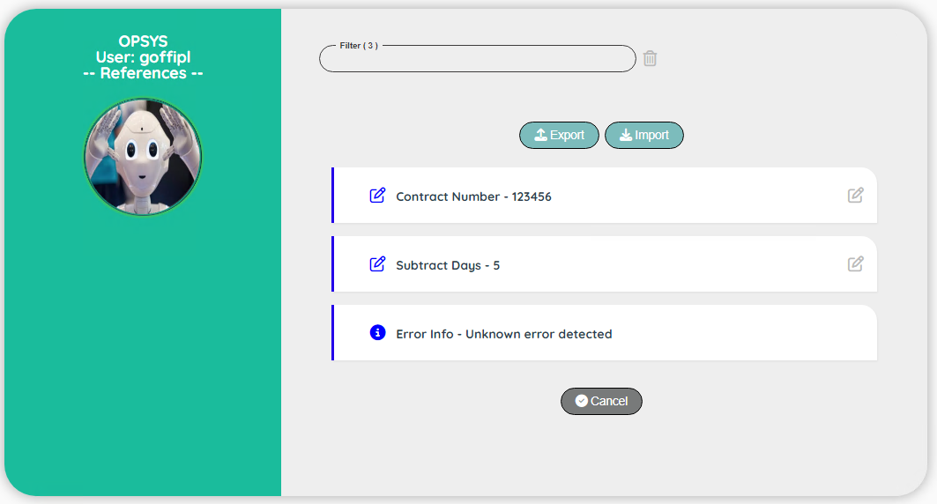

| **Topic** | **Icon** | **Comment** |
| --- | --- | --- |
| Update |  | Click to update the reference |
| Cancel |  | Back to the Dashboard screen |
| Export |  | Export a reference |
| Import |  | Import a reference |

|  |
| --- |
| Reference Edit |

If you are authorized to edit a reference, you can access to a screen to edit.

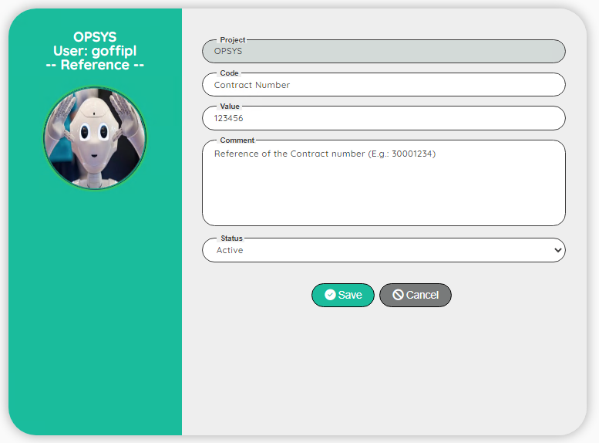

| **Topic** | **Icon** | **Comment** |
| --- | --- | --- |
| Project |  | For info: Name of the project |
| Code |  | For info: Code of the reference (do not change it) |
| Value |  | Value of the reference |
| Comment |  | For info: Comment (do not change it) |
| Active |  | For info: Status of the reference (do not change it) |
| Save |  | Save the edit |
| Cancel |  | Discard the edit |

|  |
| --- |
| Reference Export |

The reference is only visible by you, but you can export your reference to share with another user (or to take a backup to keep a trace of a progress of a story).

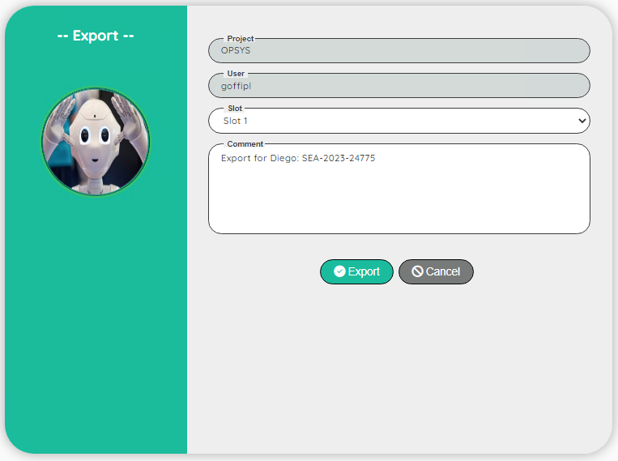

| **Topic** | **Icon** | **Comment** |
| --- | --- | --- |
| Project |  | For info: Name of the project |
| User |  | For info: your login |
| Slot |  | Slot number (10 slots available) |
| Comment |  | Comment for the export |
| Export |  | Save the export |
| Cancel |  | Discard the export |

|  |
| --- |
| Reference Import |

You can import a reference if you export one as a backup or another user agree to share with you its data.

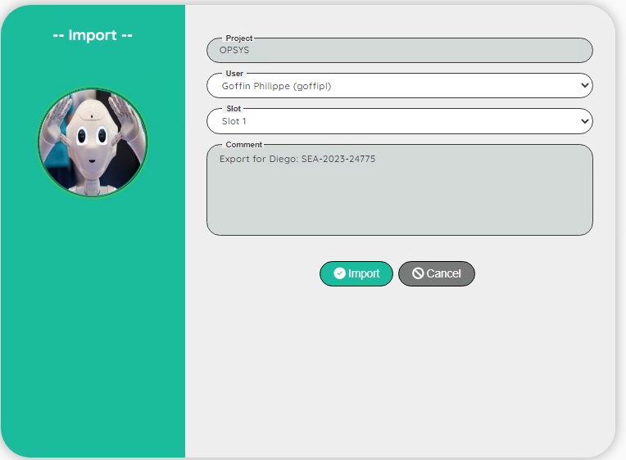

| **Topic** | **Icon** | **Comment** |
| --- | --- | --- |
| Project |  | For info: Name of the project |
| User |  | Select a user |
| Slot |  | Select a slot number (10 slots available) |
| Comment |  | For info: Comment key during the export |
| Import |  | Import a reference |
| Cancel |  | Discard the import |

# **Dataset**

|  |
| --- |
| User Interface: Dataset |

A dataset is composed of a dataset (used to group data) and a set of data.  
A dataset is global to a project / subproject but it’s common to all the users.  
A dataset starts always with #

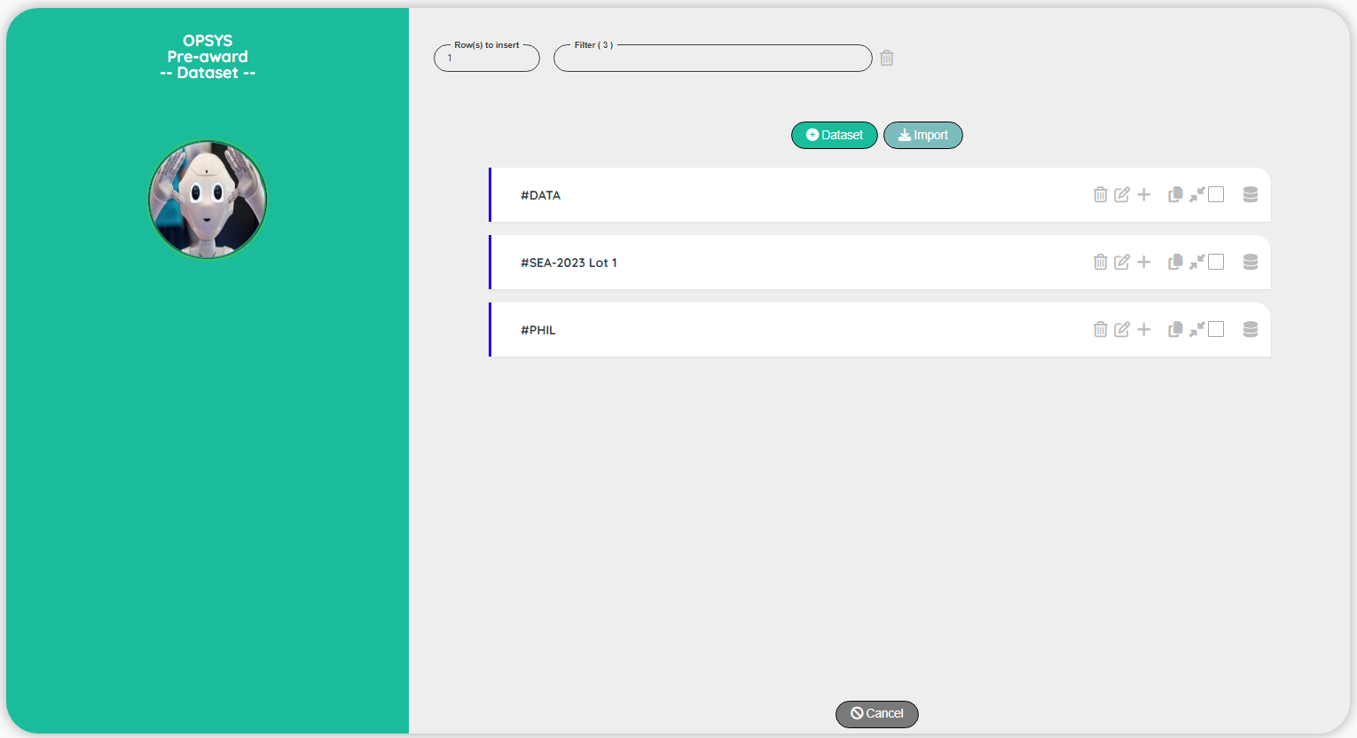

| **Topic** | **Icon** | **Comment** |
| --- | --- | --- |
| Dataset |  | Add a new dataset at the beginning of the list |
| Import |  | Import Dataset ( including data) from another project |
| Edit icons |  | See the chapter on the ‘Edit a record’ |
| Data |  | Go to the data screen |
| Cancel |  | Back to the Control Panel |

|  |
| --- |
| User Interface: Dataset Edit |

Be careful when you update an existing dataset because it will affect all the users

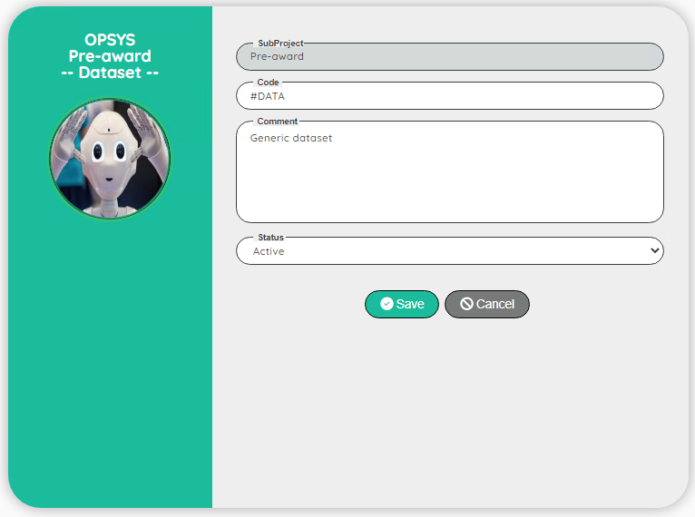

| **Topic** | **Comment** |
| --- | --- |
| Subproject | For info: Name of the subproject |
| Code | Identifier of the dataset |
| Comment | Comment on the dataset |
| Status | Active / Not Active / Comment |

|  |
| --- |
| User Interface: Dataset Import |

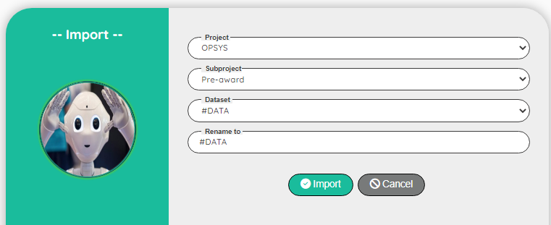

| **Topic** | **Comment** |
| --- | --- |
| Project | Select the name of the project to import dataset |
| Subproject | Select the name of the subproject to import dataset |
| Dataset | The dataset source to import |
| Rename | [Optional] You can rename the Dataset |

Note: In case the dataset already exits, the import is aborted. If necessary, you can rename the dataset and go to the data to copy the data you need (see the section: Export data into another dataset )

|  |
| --- |
| User Interface: Data |

A data starts always with _ (underscore)

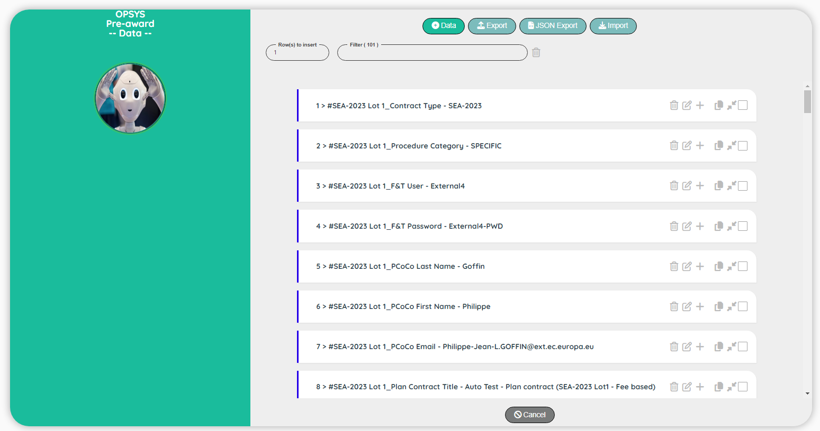

| **Topic** | **Icon** | **Comment** |
| --- | --- | --- |
| Dataset |  | Add a new dataset at the beginning of the list |
| Export |  | Export some data into another subproject |
| JSON Export |  | Export the data into a .JSON file |
| Import |  | Import data from another dataset |
| Edit icons |  | See the chapter on the ‘Edit a record’ |
| Data |  | Go to the data screen |
| Cancel |  | Back to the Control Panel |

### Export data into another dataset

Sometimes, you need to push some data from a dataset to another one.  
For instance, the data from a contract type A must be also used in the contract type B.

1. Start by selecting the data that you want to push to another dataset.

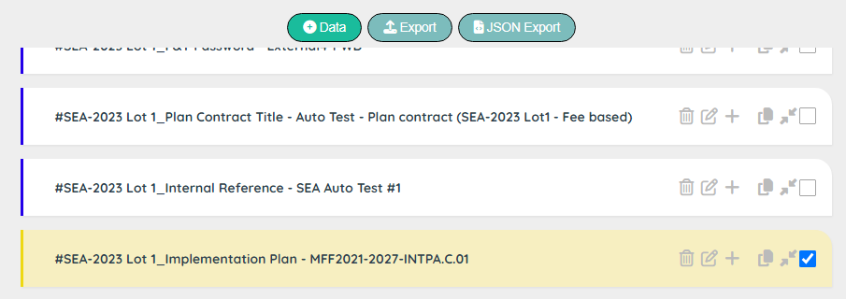

1. Click on the ‘Export’ button
2. Decide what you want to do in case the data already exists in the selected dataset:  
   a) Ignore the data  
   b) Replace the value
3. Select the dataset (from your current subproject)  
   Note: In case, you need to import data from another project, see the section ‘Import’ of the dataset header
4. Click on ‘Export’

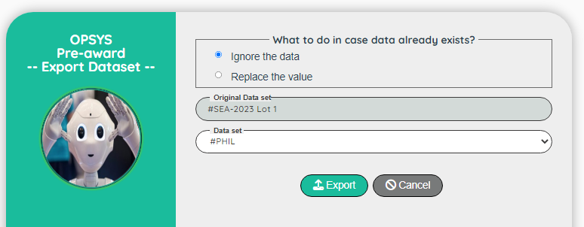

### How to process a ‘.json’ file into Excel

### Open a blank Excel workbook

* Go to the ‘Data’ section and click on ‘Get Data’

* Select the option ‘From JSON’

* Select the .json file from the folder ‘Download’ on your local driver.  
  a new window is now opened.  
  Click in the item of the menu ‘Into Table Convert’

* Click on the right icon of the cell Value and select Expand to New rows

Click again on the right icon of the cell Value and click OK

The data are now displayed into a table.  
Click the first item in the menu ‘Close & Load’

And now, you have a nice table with the data of the dataset

You can now manage this table to share with the Business Team.  
For instance, you can use this sheet as a template to execute a scenario with special values.

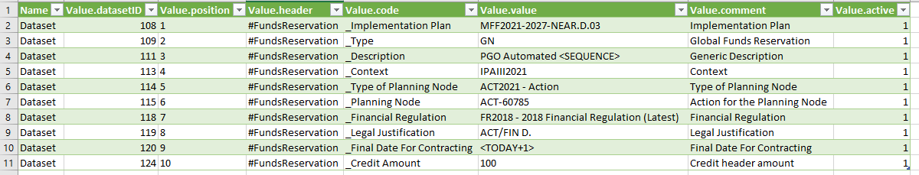

### Import data from another dataset

Sometimes, you need to import specific data stored in another dataset.  
For instance, you add a new data and it must be propagate in all the contract dataset.

1. Start by selecting the data where you need to import.  
   Select the dataset and go to the data (button: ‘manage data’)

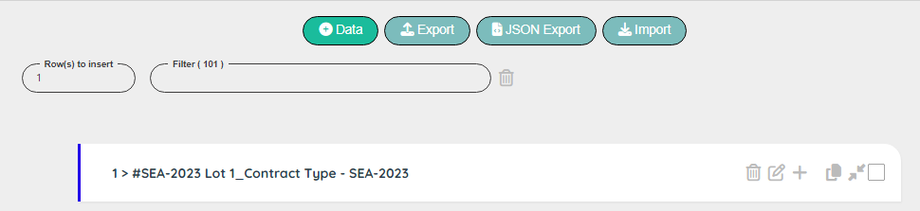

1. Click on the ‘Import’ button

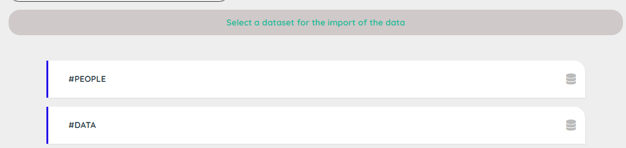

1. Select the dataset and select the data you want to import

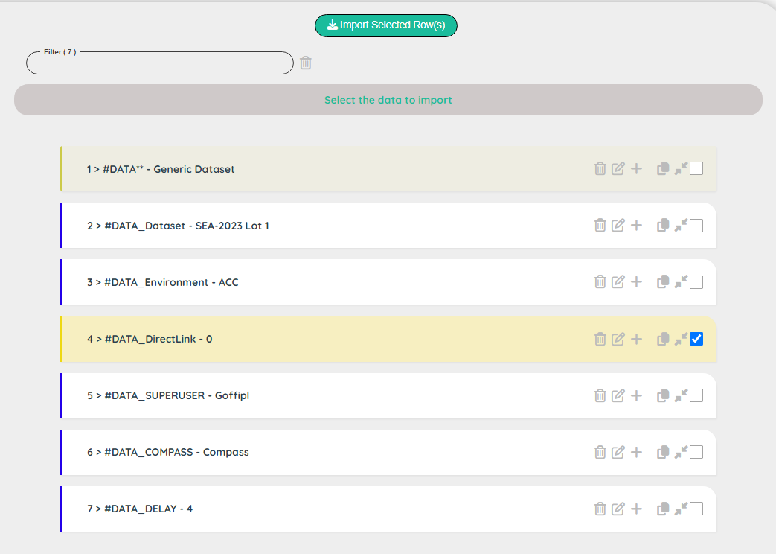

1. Click on the button “Import Selected Row(s)” to import the data in the desired dataset

|  |
| --- |
| User Interface: Data Edit |

Be careful when you update an existing data because it will affect all the users

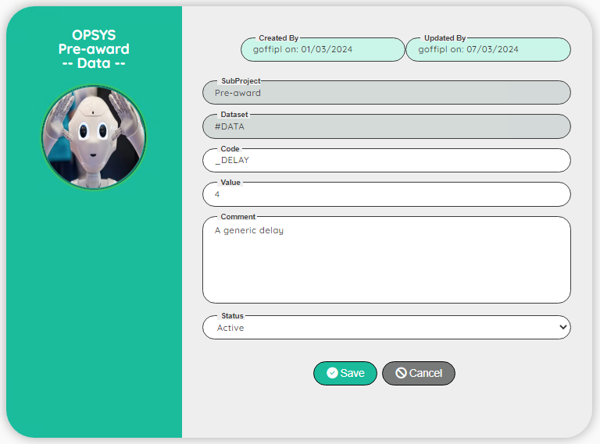

| **Topic** | **Comment** |
| --- | --- |
| Created by | For info: login and creation date |
| Updated by | For info: login and updating date |
| Subproject | For info: Name of the subproject |
| Code | Identifier of the data |
| Value | Value for the data |
| Comment | Comment on the data |
| Status | Active / Not Active / Comment |

# **Dummy User**

|  |
| --- |
| User Interface |

### The Dummy user will show you all the users that you can use for testing.

### Dummy users are global to a project.

### 

| **Topic** | **Icon** | **Comment** |
| --- | --- | --- |
| Dummy User |  | Add a new dummy user at the beginning of the list |
| Edit icons |  | See the chapter on the ‘Edit a record’ |
| Cancel |  | Back to the Control Panel |
| Green/Blue bar |  | Green: encrypted password – Blue: normal password |

|  |
| --- |
| User Interface: Edit |

### 

| **Topic** | **Comment** |
| --- | --- |
| Created by | For info: login and creation date |
| Updated by | For info: login and updating date |
| Project | For info: Name of the project |
| Dummy | Name of the dummy user for the test |
| User | Name of the real user |
| Encrypted | Yes if the password is encrypted, otherwise No |
| Password | Password of the user Click on the icon:  to encrypt the password (the encrypted filed will be set automatically to Yes) |
| Extra information | Extra information (for instance if a phone name is required for the login) |
| Active | Yes / No |